1. Well, there is literally 0 hits on PreferenceActivity or isValidFragment:

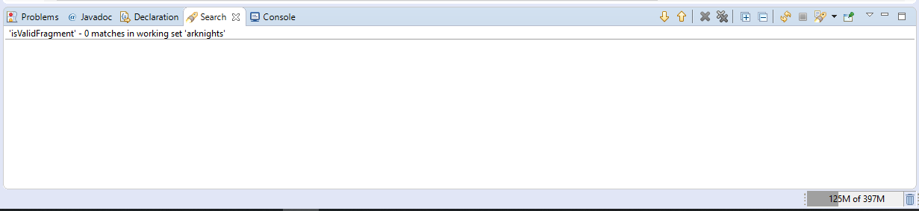

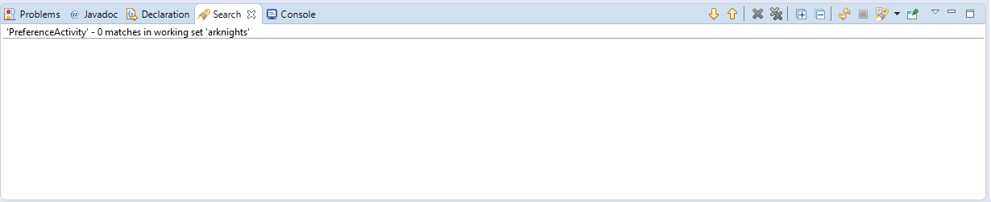

Oh well, no PreferenceActivity – no problems ☺.

1. Custom URL schemes?

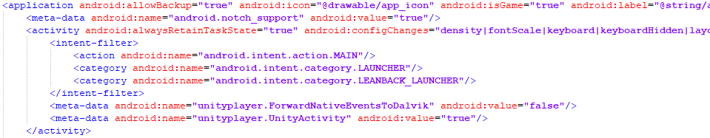

Nope.

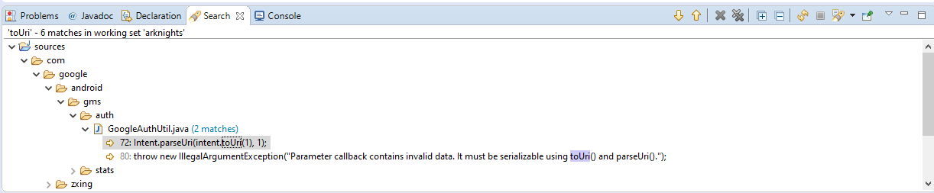

toUri I found only deep somewhere in android sdk. Nowhere in the actual app.

1. Here are things I found in AndroidManifest.xml:

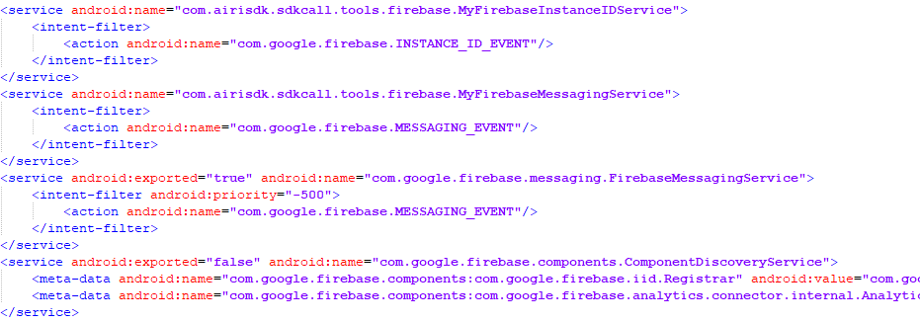

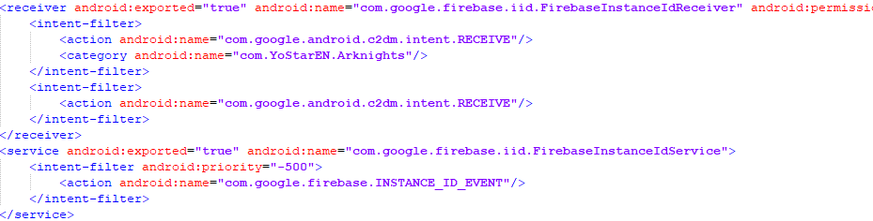

These ones are for Google Firebase, which should be exported.

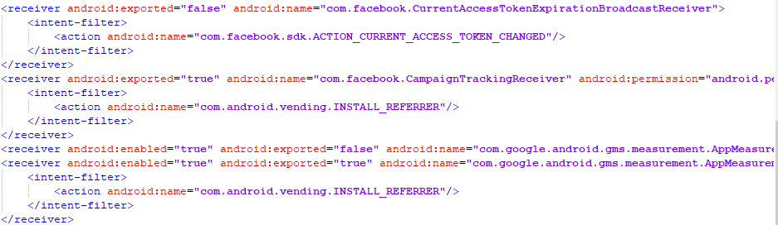

Here we can see examples of exported (CampaignTrackReceiver) and unexported (CurrentAccessTokenExpirationBroadcastReceiver).

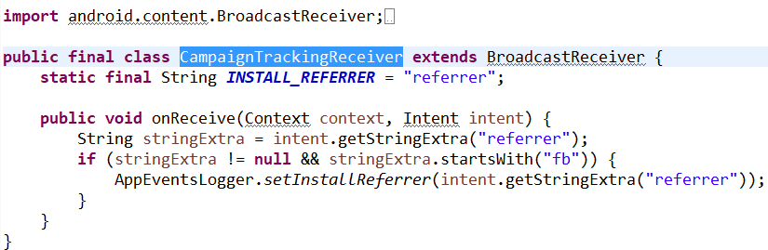

No confidential information here (as I can see at least).

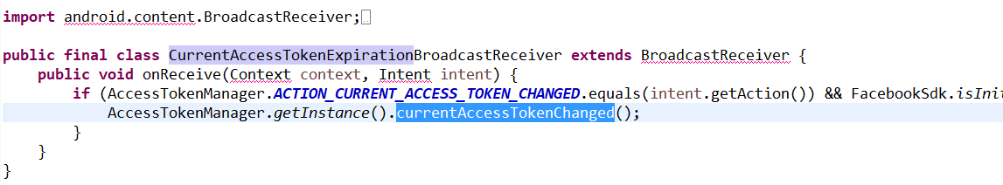

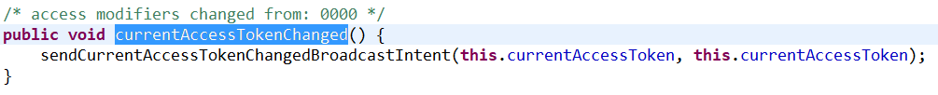

Something about current access token. Seems like confidential information for sure.

1. The only setJavaScriptEnabled I found was in bolts sdk.

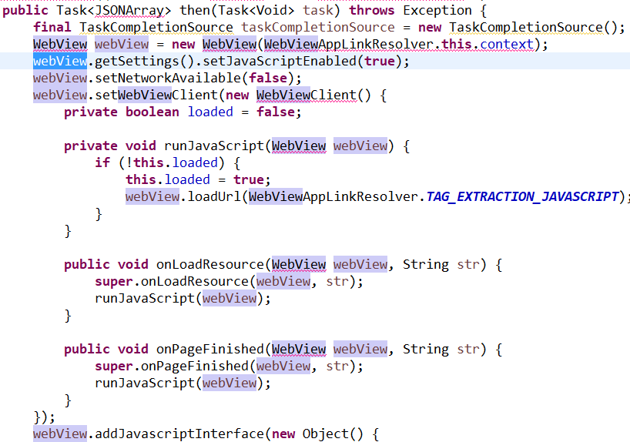

Not sure what is it all about, but in JavascriptInterface there is only that:

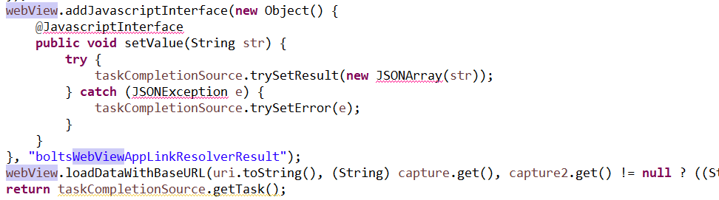

As I can see it’s not really used for javascript, but for JSON instead. Though I’m not sure.